When you use Fragments there are a lot of moving part. I always find that it’s helpful to draw pictures to help me understand how the different parts relate to each other. The diagrams below show the relationships of the different parts of the app for both Portrait and Landscape orientations.

**Portrait**

**MainActivity.cs**  (detects single-pane layout) **TranslateActivity.cs**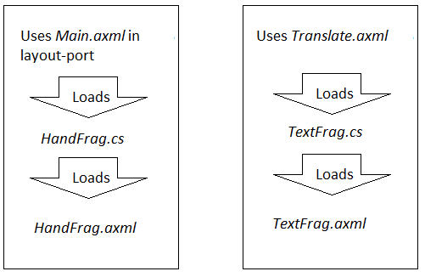

**Landscape**

**MainActivity.cs** (detects dual-pane layout)

